# **CTF Challenge: Footprinting - Using WhatIsMyIP**



# **1. Introduction**

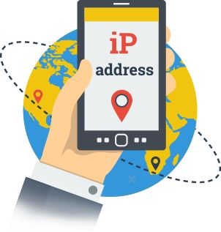

WhatIsMyIP is a tool that provides detailed information about your IP address, including your ISP, location, and more. This challenge will introduce you to using WhatIsMyIP to gather information about your IP address.

# **2. Tools and requirements**

* Access to the internet and Search for Whatismyip

## **3. Scenario**

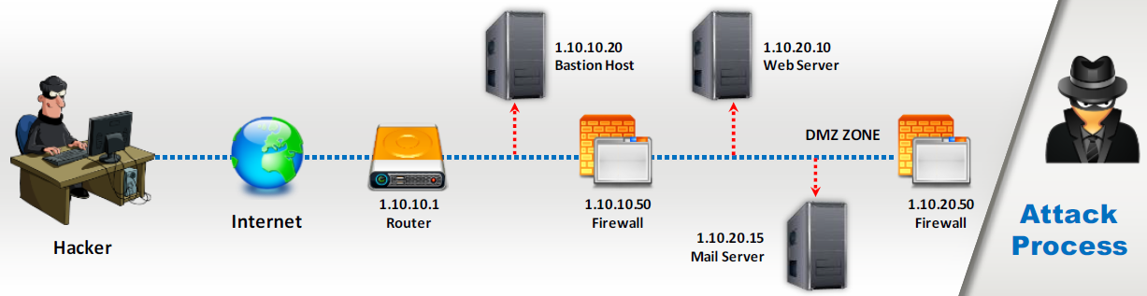

You are an ethical hacker tasked with gathering information about your IP address using WhatIsMyIP. Your job is to find the ISP and location of your IP address.

# **4. Process to follow while performing CTF**

**1.Visit WhatIsMyIP:** [**https://whatismyipaddress.com/ip-lookup**](https://whatismyipaddress.com/ip-lookup)

**2.Perform the Lookup:** search for **128.125.52.138** Record the ISP and location from the results.

# **5. Let’s Begin the Challenge**

**Questions:**

Flag 1: What is the Internet service provider of IP addresses?

Answer: Amazon Technologies Inc.

Flag Captured

Flag 2: What is the Location of IP Address?

Answer: United States

Flag Captured

Flag 3: Is IP Address Static or dynamic.

Answer: Static

Flag Captured

Flag 4: Is this IP Address listed black or not.

Answer: Not listed

Flag Captured

**Hint**

* Use WhatIsMyIP to perform the lookup.

